Project Images and Notes
Sunday, June 10, 2018
1:44 PM

1985 Auto Imports Database Analyses

Dataset:
https://www.kaggle.com/ashishpal2702/1985-auto-imports-database-analyses-prediction

Objective:
We would like to examine predict the price of a car based on the effect of physical and performance car attributes while holding the insurance risk rating constant. again.

Variable list sensitive to the objective:

Physical Car attributes
  - make: [ Manufacturer name eg : alfa-romero, audi, bmw, chevrolet, dodge, honda,isuzu etc. ]
  - num-of-doors: [four, two].
  - body-style: [hardtop, wagon, sedan, hatchback, convertible]
  - engine-location: [front, rear]
  - wheel-base: [continuous from 86.6 120.9]
  - length: [continuous from 141.1 to 208.1]
  - width: [continuous from 60.3 to 72.3]
  - height: [continuous from 47.8 to 59.8]
  - curb-weight: [continuous from 1488 to 4066]

Performance attributes
  - fuel-type: [diesel, gas]
  - aspiration: [std, turbo]
  - drive-wheels: [4wd, fwd, rwd]
  - engine-type: [dohc, dohcv, l, ohc, ohcf, ohcv, rotor]
  - num-of-cylinders: [eight, five, four, six, three, twelve, two]
  - engine-size: [continuous from 61 to 326]
  - fuel-system: [1bbl, 2bbl, 4bbl, idi, mfi, mpfi, spdi, spfi]
  - bore: [continuous from 2.54 to 3.94]
  - stroke: [continuous from 2.07 to 4.17]
  - compression-ratio: [continuous from 7 to 23]
  - horsepower: [continuous from 48 to 288]
  - peak-rpm: [continuous from 4150 to 6600]
  - city-mpg: [continuous from 13 to 49]
  - highway-mpg: [continuous from 16 to 54]

Insurance Risk attributes
  - normalized-losses: [average loss payment per insured vehicle year -> continuous from 65 to 256.]
  - symboling: [its assigned insurance risk rating -> [-3, -2, -1, 0, 1, 2, 3]]

Response Variable
  - Price

Data Sets
Original

41 data points were missing from Normalized Losses variable. We chose to remove this variable from the dataset in order to preserve as many records as possible. This variable is not reliable enough to keep in the analysis.

/*Import dataset with formatted columns*/
data auto;
infile '/home/carollr0/DataSets/Automobile_data.csv' dlm=',' firstobs=2;
input symboling normalizedlosses
make $ fueltype $ aspiration $ numofdoors $
bodystyle $ drivewheels $ enginelocation $ wheelbase length width height
curbweight enginetype $ numofcylinders $ enginesize fuelsystem $ bore stroke
compressionratio horsepower peakrpm citympg highwaympg price;
run;

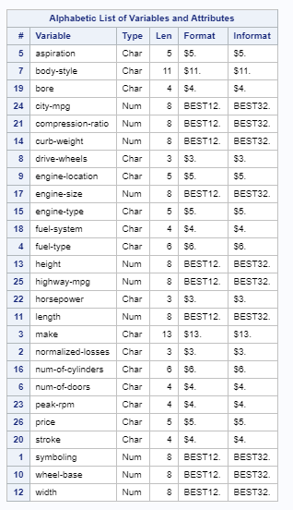

/*Descriptive Statistics for Numeric Variables*/
ods noproctitle;
ods graphics / imagemap=on;

proc means data=auto2 chartype mean std min max n nmiss vardef=df;
var symboling wheelbase length width height curbweight
enginesize bore stroke compressionratio horsepower peakrpm citympg highwaympg
price;
run;

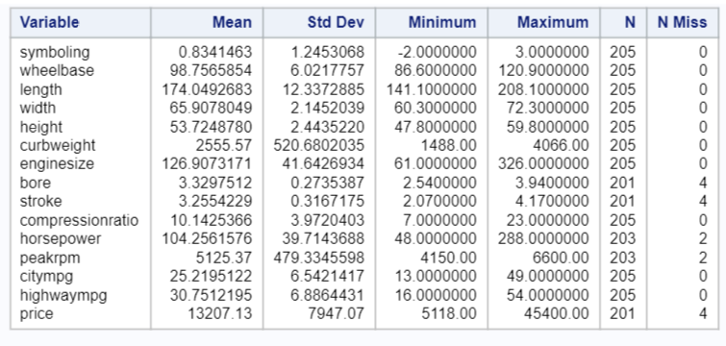

Cleaned Data - removed all rows/records with missing data

/*Delete rows with missing data - equates to 10 records removed */
data auto_clean;
set auto;

if nmiss(of _numeric_, 1) + cmiss(of _character_, '?') then
delete;
run;

/*Descriptive Statistics for Numeric Variables*/
ods noproctitle;
ods graphics / imagemap=on;

proc means data=WORK.AUTO_CLEAN chartype mean std min max n nmiss vardef=df;
var symboling wheelbase length width height curbweight
enginesize bore stroke compressionratio horsepower peakrpm citympg highwaympg
price;
run;

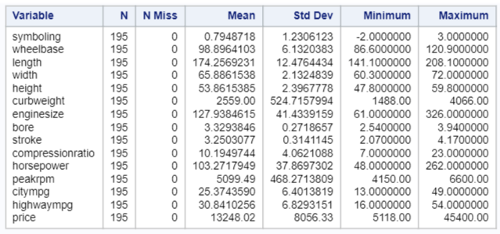

Deleted Data -

/*Data set created - Deleted rows with missing data*/
data auto_clean_missing;
set auto_clean;
if nmiss(of _numeric_, 1) + cmiss(of _character_, '?') then
output;
run;

./*Analyze the deleted records*/
/*Descriptive Statistics for Numeric Variables*/
ods noproctitle;
ods graphics / imagemap=on;

proc means data=auto_clean_missing chartype mean std min max n nmiss vardef=df;
var symboling wheelbase length width height curbweight
enginesize bore stroke compressionratio horsepower peakrpm citympg highwaympg
price;
run;

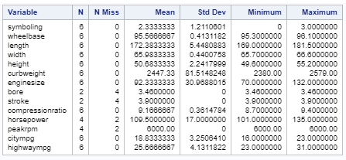

We compared the descriptive stats for Original dataset against the Cleaned dataset and the deleted record dataset.
The means of the deleted items are within range of the original data. We conclude it is safe to delete the 10 records
that contain missing data points.

Exploratory Analysis
Scatter Plot Matrix of all numerical variables

/*Plot all numeric variables against each other*/
options validvarname=any;
ods noproctitle;
ods graphics / imagemap=on;

/* Scatter plot matrix macro */
%macro scatterPlotMatrix(xVars=, title=, groupVar=);
proc sgscatter data=WORK.AUTO_Clean;
matrix &xVars / %if(&groupVar ne %str()) %then
%do;
group=&groupVar legend=(sortorder=ascending) %end;
diagonal=(histogram normal);
title &title;
run;

title;
%mend scatterPlotMatrix;

%scatterPlotMatrix(xVars=symboling wheelbase length width
height curbweight enginesize bore stroke compressionratio horsepower peakrpm
citympg highwaympg price, title="Clean Dataset - Scatter plot matrix",
groupVar=);

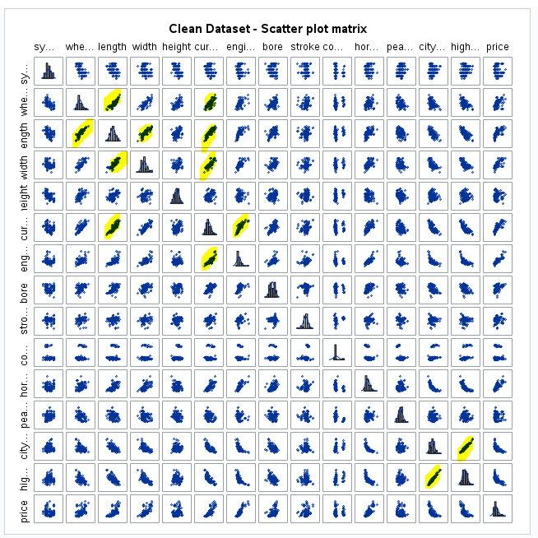

proc corr data=auto_clean plots=matrix (histogram);
run;

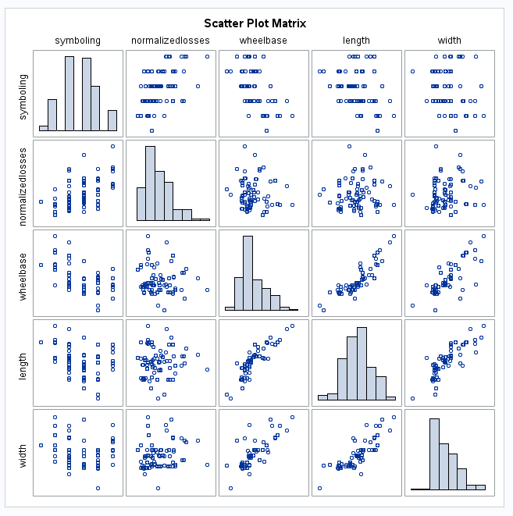

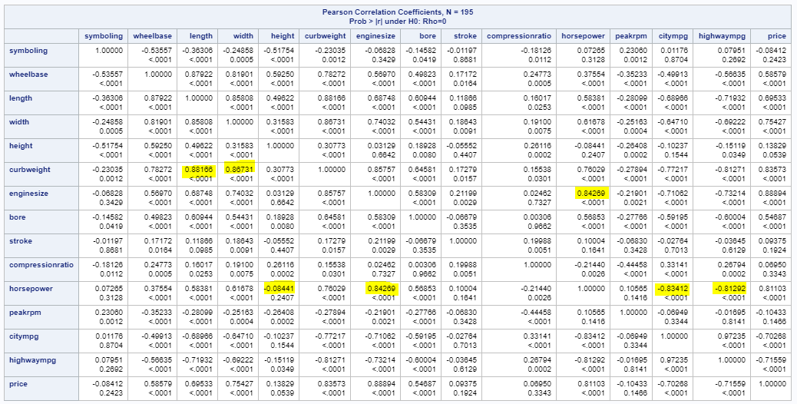

Initial look at Correlated variables

Highway MPG and City MPG
Length and Wheelbase
Width and Length
Wheelbase and Cure weight
Width and Curb weight
Engine Size and Curb weight
Engine Size and Horsepower

The following features are being removed because of their high correlation with other features.
Curb Weight
Wheelbase
Highway MPG

Residual Plots, Outliers and Leverage

Proc univariate data=auto_clean;
var symboling /*wheelbase*/
length width height /*curbweight*/
enginesize bore stroke compressionratio horsepower peakrpm
citympg /*highwaympg*/;
histogram;
run;

proc print data=work.auto_clean; run;

Symboling  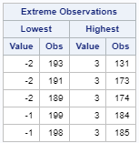  Screen clipping taken: 6/13/2018 8:01 AM | Length  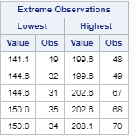  Screen clipping taken: 6/13/2018 8:02 AM | Width  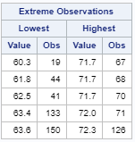  Screen clipping taken: 6/13/2018 8:02 AM | Height  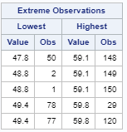  Screen clipping taken: 6/13/2018 8:03 AM
Enginesize  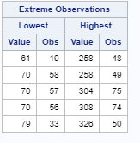  Screen clipping taken: 6/13/2018 7:59 AM | Bore  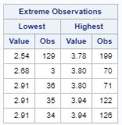  Screen clipping taken: 6/13/2018 8:03 AM | Stroke  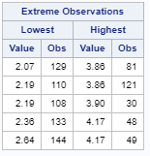  Screen clipping taken: 6/13/2018 8:03 AM | Compression ratio  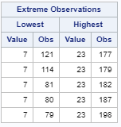  Screen clipping taken: 6/13/2018 8:04 AM
Horsepower  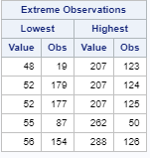  Screen clipping taken: 6/13/2018 8:04 AM | Peak RPM  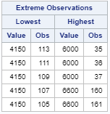  Screen clipping taken: 6/13/2018 8:04 AM | City MPG  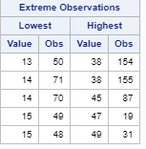  Screen clipping taken: 6/13/2018 8:05 AM

/*Dealing with Many Explanatory Variables
#Check residuals to be normally distributed but not individual variables in matrix,
#Fix any outliers - use proc univariate to point out outliers "Extreme Observations"
*/

Proc reg data=work.auto_clean plots(label)=(rstudentbyleverage cooksd);
Model price = symboling length width height enginesize bore stroke compressionratio horsepower peakrpm citympg /VIF;
run;
quit;

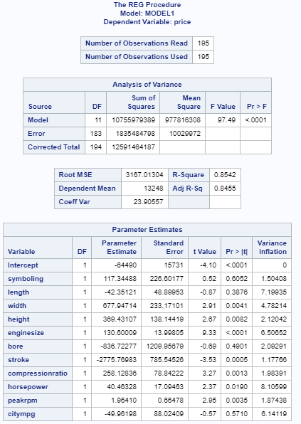

Screen clipping taken: 6/13/2018 8:14 PM

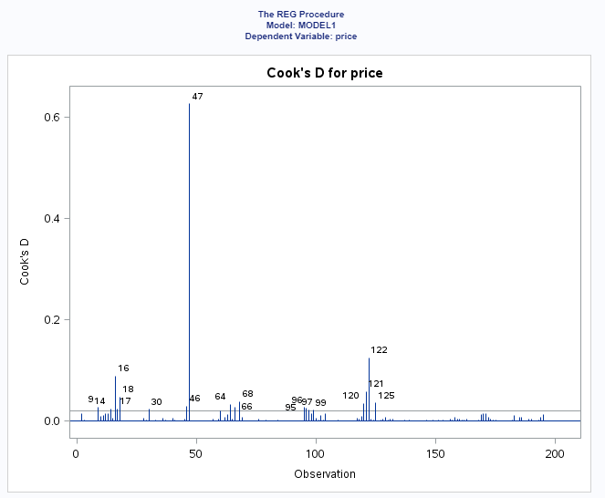

Screen clipping taken: 6/13/2018 8:14 PM

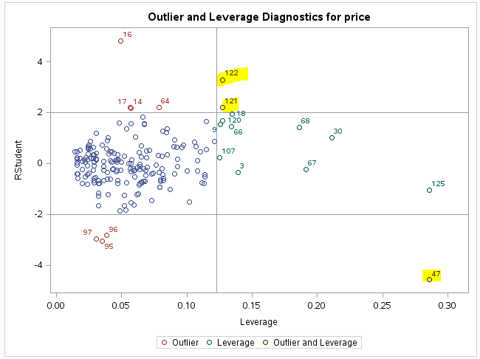

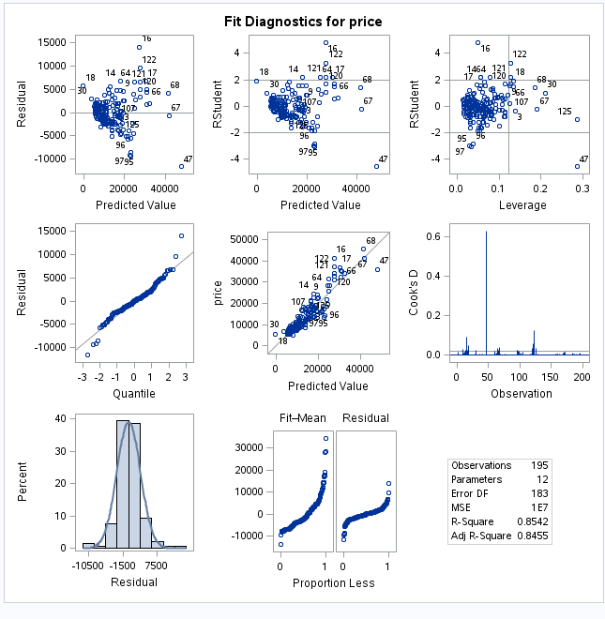

/*Observations 47, 120 and 121 are shown to be leverage and outliers but only observation 47 had a higher Cooks'D and leverage.Observation 47 will be removed.*/

data auto_remobs;
set work.auto_clean;
if _N_=47 then delete;
run;
quit;
proc print data=auto_remobs; run;

/*Re-Run residuals with corr
The Cooks'd for observation 47 was .06. The remaining indicated outliers/leverage points are now below 0.1. The remaining outliers will be included as is.
*/
Proc reg data=work.auto_remobs plots(label)=(rstudentbyleverage cooksd);
Model price = symboling length width height enginesize bore stroke compressionratio horsepower peakrpm citympg /VIF;
run;
quit;

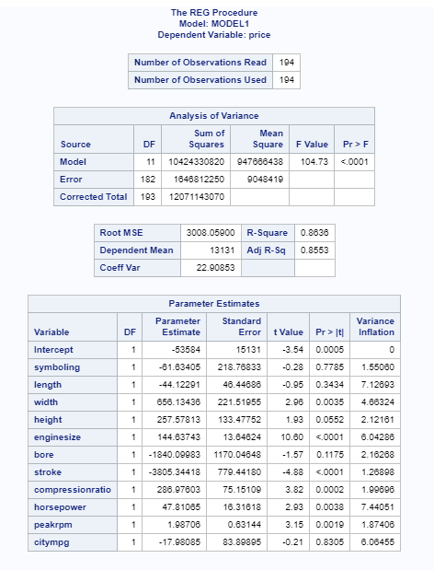

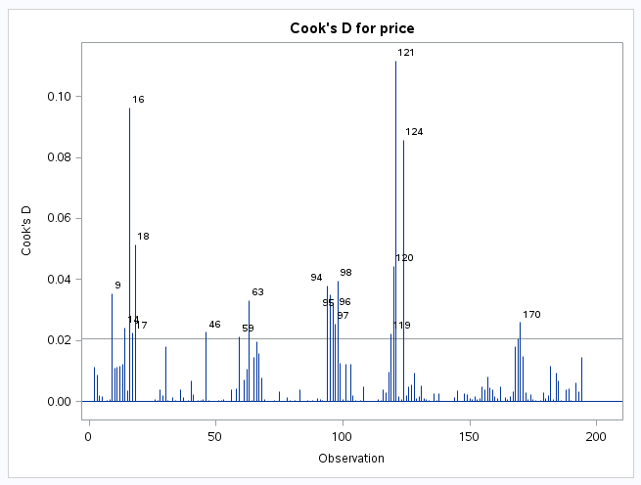 | 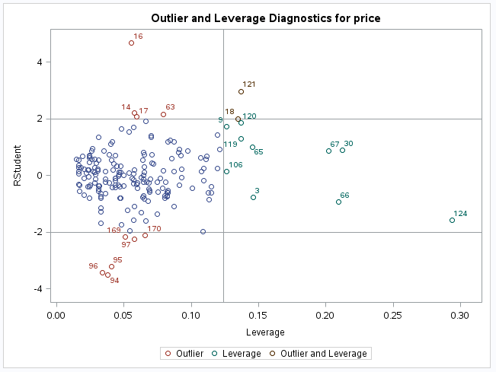

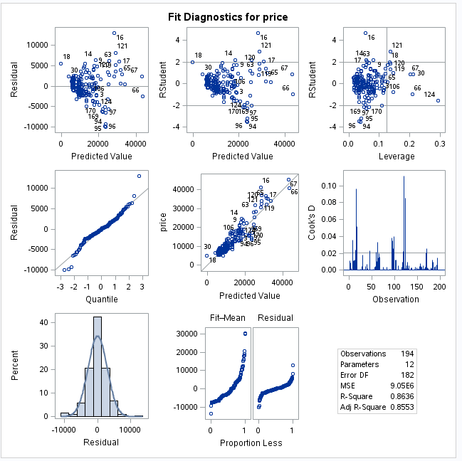

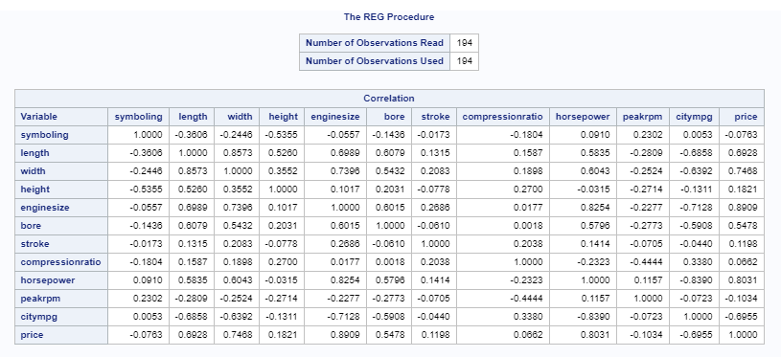

City MPG and Horsepower show to be highly correlated but the VIF show them to both be 7. We will proceed with both features since horsepower is an important car performance feature.

Assumptions
Linearity - The relationship between the dependent variable and the continuous independent variables are linear
Normality – Residuals of the linear model are normally distributed
Equal Variance – The variance of the residuals is constant for every combination of independent variables and thus constant across all of the predicted values
Independence – Observations are assumed to be independent based on the study description. The car make is indicated but not the model. All we know is that these are cars from 1985 line. We proceed with caution. In future I would try to obtain the model information for the observation to be certain the observations are independent.

Finding Subset of Variables

/*Variable Selection techinques - LARS*/
Proc glmselect data=work.auto_remobs seed=12;
Class make numofcylinders;
Model price = symboling wheelbase length width height curbweight enginesize bore
stroke compressionratio horsepower peakrpm citympg highwaympg | numofcylinders make /
selection=LAR (choose=cv stop=cv) CVDETAILS;
Run;
quit;

Fit Statistics26KGP8

The optimal model using LARS variable selection has 9 features selected. Although the Adj R Square shows that 85% of the variation in price is explained by the 9 features. We will look at LASSO variable selection model next.

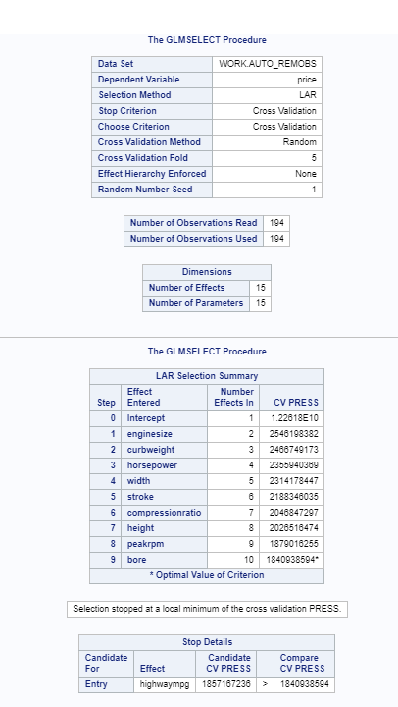

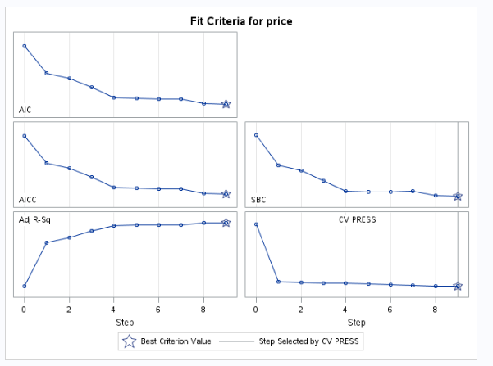

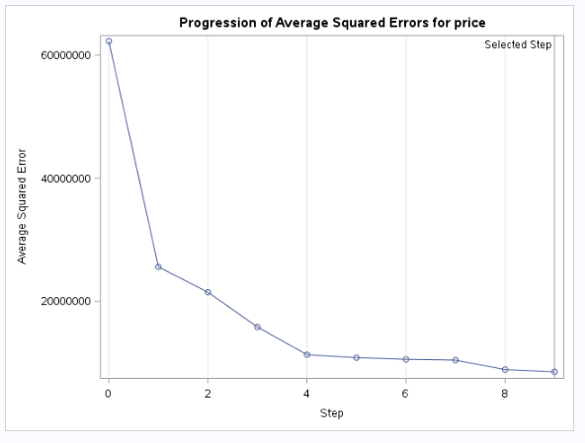

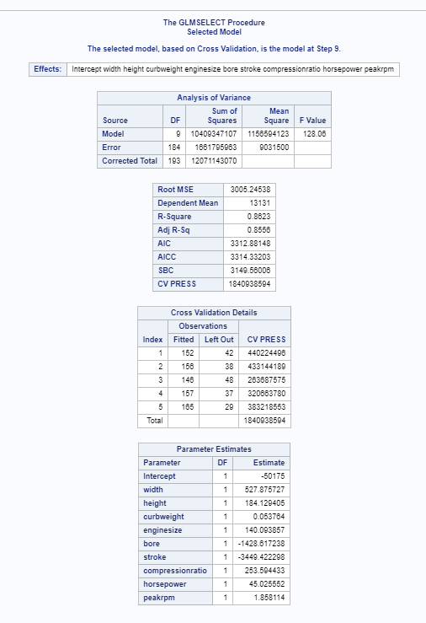

/*Variable Selection techinques - LASSO*/

proc glmselect data=work.auto_remobs plots(stepaxis=number)=(criterionpanel ASEPlot) seed=1;
partition fraction(test=.5);
Model price=symboling wheelbase length width height curbweight enginesize bore
stroke compressionratio horsepower peakrpm citympg highwaympg /
selection=lasso(choose=cv stop=cv) CVDETAILS;
run;

Fit Statistics

The optimal model using LASSO variable selection has 4 features selected. The Adj R Square shows that 73% of the variation in price is explained by the 4 features. Although the Adj R Square is lower than the LARS model, the SBC is smaller and the interpretation simpler with 4 features.

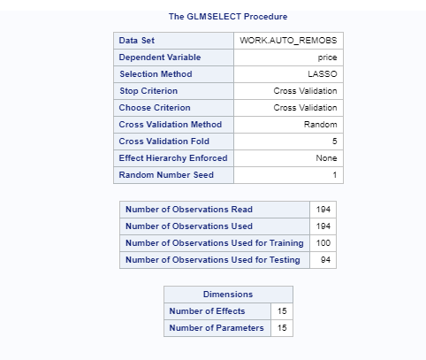

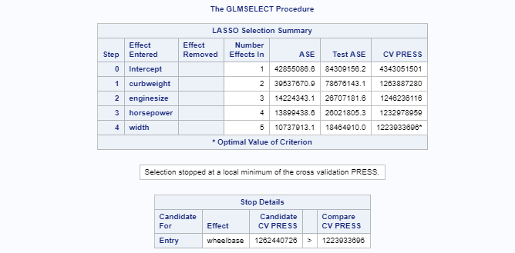

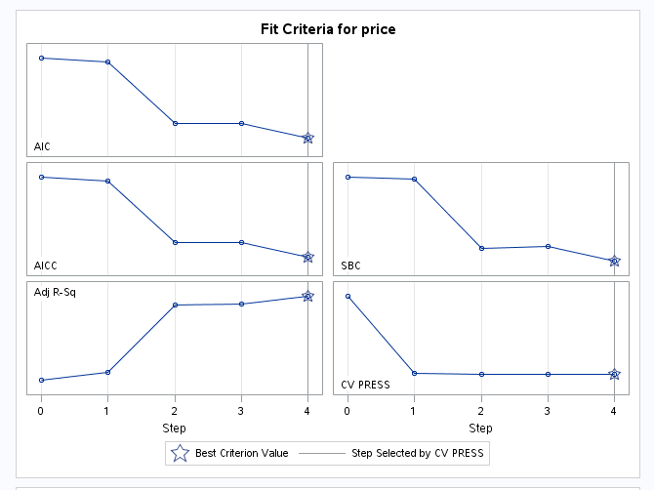

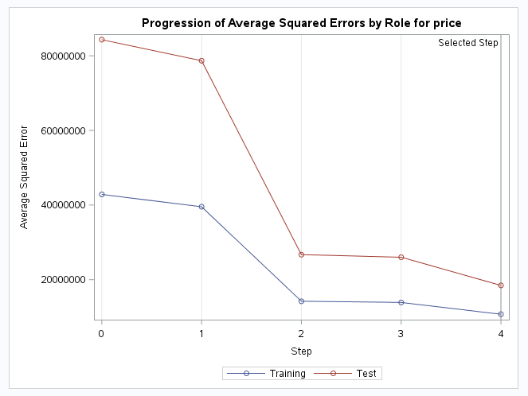

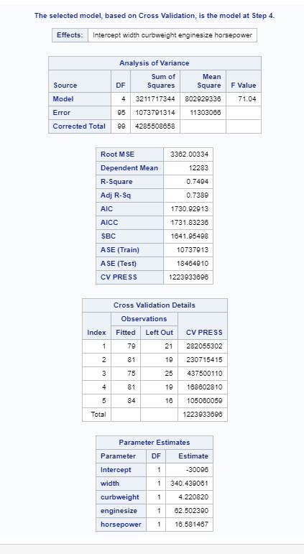

/*Run Selected Model (LASSO)*/
Proc reg data=work.auto_remobs;
Model price= width curbweight enginesize horsepower /partial;
run;
quit;

Assumptions
Leverage is at .30 which is good.
QQ Plot shows normally distributed residuals.
Partial plots show curbweight to not have a significant slope.
The p value for curbweight shows to be .39. We will remove this feature and re-run proc reg.

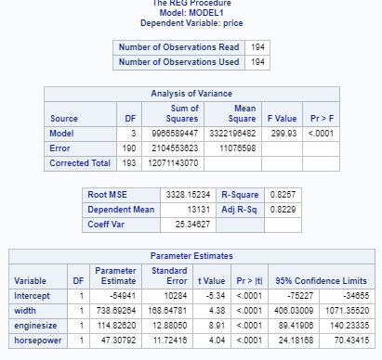

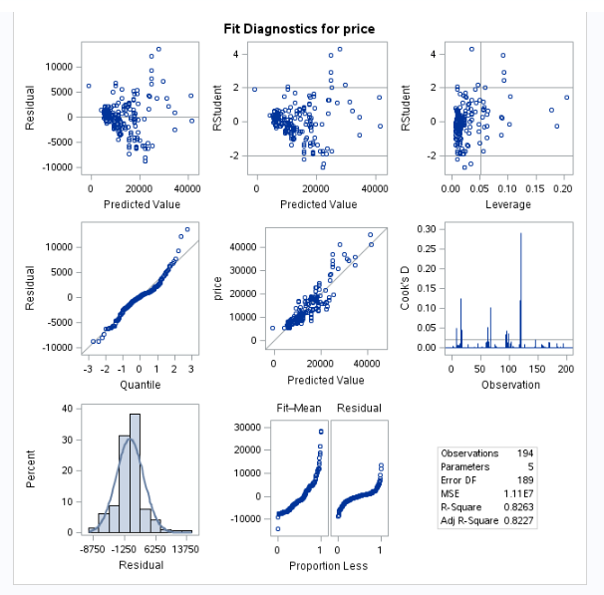

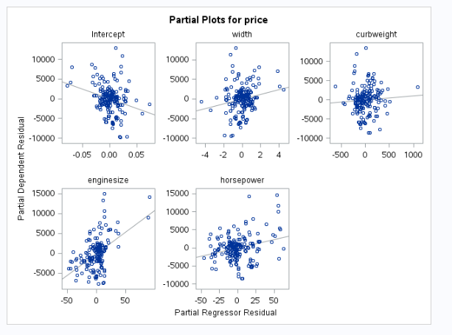

/*Final model selection*/
Proc reg data=work.auto_remobs;
Model price= width enginesize horsepower /partial;
run;
quit;

Assumptions
Leverage is at .30 which is good.
QQ Plot shows normally distributed residuals.
Variance????

Final Model

Price = -54941 + 738.69264(width) + 114.82620(engine size) + 47.30792(horsepower)
For every one unit increase in width, the expected increase in price is 738.69 holding engine size and horsepower constant.
For every one unit increase in engine size, the expected increase in price is 114.82 holding engine size and horsepower constant..
For every one unit increase in horsepower, the expected increase in price is 47.30 holding engine size and horsepower constant..

Is width of a car a useful predictor of the car price after accounting for the effect of engine size and horsepower?
We are 95% confidence that the true regression coefficient width for predictor price is between (406.03, 1071.35).
We are 95% confidence that the true regression coefficient engine size for predictor price is between (89.42, 140.23).
We are 95% confidence that the true regression coefficient horsepower for predictor price is between (24.18, 70.43).

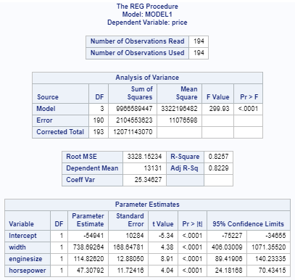

Screen clipping taken: 6/14/2018 6:28 PM

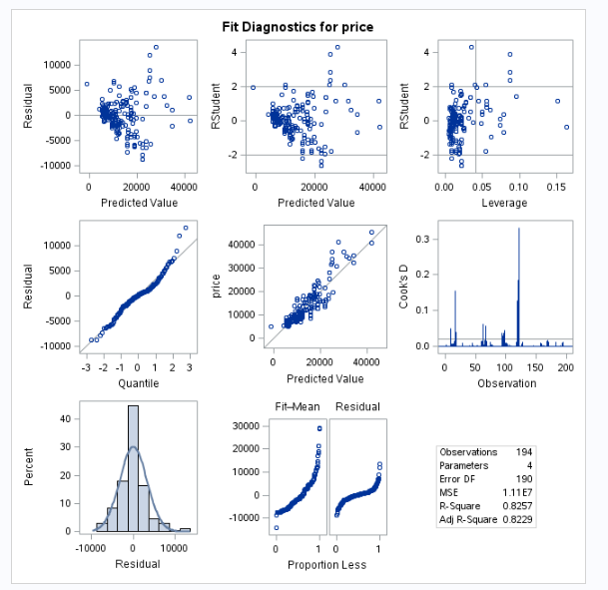

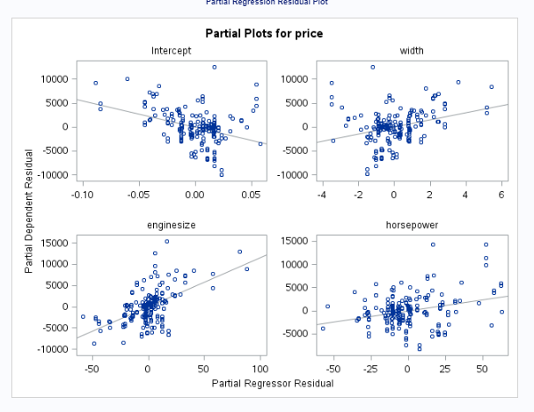

/*Predicted values and prediction intervals*/
proc glm data=work.auto_remobs plots=all;
Model price= width enginesize horsepower/ cli solution;
output out = resultsC p=Predict;
run;

The model was built on low number of observation which is causing our CI to be wide.
